VOICE FIRST AGENTIC AI SYSTEM
PRAKHAR RAWAT
MTECH CSE (2024-26)
A124006

Architecture Document
1. System Overview
This project implements a voice-first, agentic AI system that helps users identify and (theoretically) apply for government welfare schemes using a native Indian language (Hindi). The system goes beyond a chatbot by demonstrating planning, decision-making, tool usage, memory, and failure handling.
The agent operates end-to-end using voice:

2. High-Level Architecture

3. Agent Lifecycle
The agent follows an explicit Planner–Executor–Evaluator loop:
- Planner
  - Determines which user information is missing (age, gender, income, caste)
  - Decides the next question to ask
- Executor
  - Captures voice input (STT tool)
  - Extracts structured values using an LLM parsing tool
  - Calls the eligibility engine tool
- Evaluator
  - Validates extracted values
  - Detects ambiguity or contradictions
  - Requests clarification or proceeds
- Memory Update
  - Stores validated user attributes
- Action / Response
  - Returns scheme eligibility via voice
This loop repeats until the task is completed or reset.

4. Decision Flow
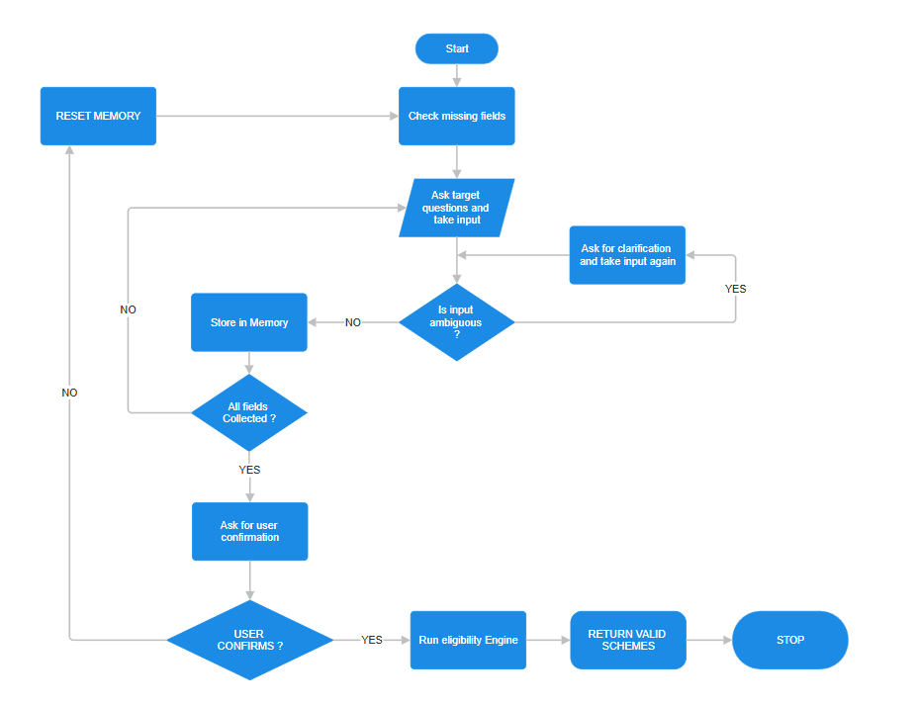

5. Memory Architecture
Memory Type | Description
Short-term memory | Current conversation state (user_data)
Slot memory | Structured fields (age, gender, income, caste)
Conflict handling | Ambiguous or contradictory inputs trigger re-asks

Memory persists across turns until task completion.

6. Prompt Design
Parsing Prompt (Executor Tool)
- Extracts only structured values from free-form speech
- Enforces controlled outputs (digits, MALE/FEMALE, caste labels)
Evaluator Logic
- Rule-based ambiguity detection
- Confirmation step before final execution
No open-ended generation is allowed during decision steps.

7. Tool Integration
Tool | Purpose
Speech-to-Text (Whisper) | Convert Hindi speech to text
LLM Parsing Tool | Normalize user inputs
Eligibility Engine | Match schemes based on rules
Text-to-Speech | Voice output

8. Failure Handling
Failure Type | Handling Strategy
No audio detected | Ask user to repeat
Ambiguous response | Reject and re-ask
Wrong confirmation | Reset conversation
No scheme found | Inform user gracefully

9. Application (Theoretical Extension)
After eligibility identification, the agent can:
- Confirm intent to apply
- Collect required documents (mock)
- Submit data to a mock API
- Provide application confirmation
This satisfies the "identify and apply" requirement without real government integration.

10. Conclusion
This architecture demonstrates a true agentic AI system with voice-first interaction, structured reasoning, tool orchestration, memory, and failure recovery, fully aligned with the assignment requirements.

